

**PROJECT**

**PROPOSAL**

## 

**PATOCY**

Your passion is your career

### **PREPARED BY**

Team 10

TABLE OF CONTENTS

**1. PROBLEM 4**

1.1 Introduction 4

1.2 Background and stat 4

1.3 Example 5

**2. PROPOSED SOLUTION 6**

2.1 Project Proposed 6

2.2 System Diagram 6

**3. TARGET AUDIENCE 8**

3.1 High school and college students 8

3.2 Career changers seeking new opportunities 8

3.3 Guidance counselors 9

3.4 Education institutes 9

**4. FEATURES OF THE SYSTEM 10**

**5. RESOURCE REQUIREMENT 12**

5.1 HARDWARE 12

5.2 SOFTWARE 12

5.3 TECH STACK 12

**6. BUSINESS MODEL 14**

**7. REVENUE MODEL 15**

7.1 Package services (Students-counselors) 15

7.2 Educational Institution Partnerships 15

7.3 Additional Revenue Streams 15

**8. ADVERTISING 16**

**9. COMPETITOR ANALYSIS 17**

**10. NEXT STEP 18**

10.1 Feature Sets 18

10.2 Alpha Testing 18

10.3 Beta Testing 18

10.4 Marketing Field 19

10.5 Continuous Maintenance and Improvement 19

**11. SUMMARY 20**

**12. REFERENCES 21**

**ABSTRACT**  
The burgeoning growth of Sri Lanka's IT sector underscores the pressing need for a proficient and knowledgeable workforce. However, many students completing their Advanced Level (A/L) examinations often find themselves lacking the necessary guidance and resources to navigate potential career paths within the IT domain, aligned with their aptitudes and interests. Recognizing this gap, we have developed a tailored platform aimed at guiding Sri Lankan students towards fulfilling careers in IT. Our platform serves as a comprehensive resource, empowering students to explore diverse career options within the IT sector based on their individual skills and passions. By leveraging our solution, students can conduct in-depth research and discern the most suitable career pathways tailored to their unique strengths and aspirations. Through strategic alignment of skills and interests, our platform equips students with the necessary insights to make informed decisions regarding their professional trajectories. In essence, our initiative represents a significant contribution to the Sri Lankan educational landscape, offering invaluable guidance to A/L students and facilitating informed career choices. By bridging the gap between education and industry needs, we aim to cultivate a proficient and agile cohort of IT professionals poised to meet the evolving demands of the sector. Initially launched as a web-based platform, we have subsequently expanded our reach across various platforms, ensuring accessibility to a wider audience of aspiring IT professionals. Moreover, our platform facilitates access to essential courses and degree programs pertinent to IT careers, further enriching the learning journey of our users. In summary, "Patocy" stands as a pioneering solution, poised to revolutionize career guidance for A/L students in Sri Lanka. By fostering informed decision-making and nurturing a skilled IT workforce, we aspire to catalyze positive transformations within the nation's educational and technological landscape, shaping a brighter future for generations to come.

# PROBLEM

## 1.1 Introduction

A prevalent misconception among Sri Lankan school leavers is the belief that software engineering encompasses the entirety of the IT industry. Regrettably, many are unaware of the diverse array of specialized fields within IT, such as UI/UX design, cloud engineering, and network engineering. Despite this lack of awareness, a significant number of students still opt for software engineering as their intended career path. Tragically, some of these individuals encounter difficulties and ultimately fail to thrive in this field, experiencing heightened levels of stress stemming from the misalignment between their chosen career and their true passions.

## 1.2 Background and stat

Many Sri Lankan school leavers erroneously believe that software engineering represents the entirety of the IT industry, unaware of the existence of specialized fields such as UI/UX design, cloud engineering, network engineering, and others. Nevertheless, a considerable number still opt for software engineering as their intended career path. Regrettably, some of these individuals encounter failure and experience the stress of pursuing a career that does not align with their true passions.

* The study "Role of Passion in Career Choices of University Students" by Aishwarya Marathe and Rekha Wagani discusses how choosing a career aligned with one's passion leads to greater meaningfulness, satisfaction, and fulfillment, whereas those who pursue different careers may experience frustration and dissatisfaction. **(**Marathe, A & Wagani, R 2022)
* The article "Why Passion is Important for Success in Work and Life" by GP LeBourdais emphasizes the significance of passion in both learning outcomes and overall success. It asserts that individuals exhibit enhanced learning abilities when they approach subjects with curiosity and passion, thereby fostering greater academic optimism and success.(LeBourdais, G.P. (2023))
* The "Passion Project" program, facilitated by the IEG Global Association, offers students the chance to engage in projects that align with their interests, thereby enhancing their research skills and creativity. Over 75% of Harvard students who participated in a Passion Project reported a positive impact on their application results, underscoring the benefits of pursuing one's passion.(Anon, (2021). *Passion Project - IEG Global Association*.)

## 1.3 Example

Meanwhile, some students who completed their advanced level exams in 2021 are embarking on careers as software engineers due to advice from their parents, relatives, and friends, who tout the IT industry as the optimal choice. They enroll in university degree programs where a subset of students secure internships in software engineering. However, after a few years, some find themselves overwhelmed by stress and struggle to maintain their careers. Some realize that their passion does not lie in coding and opt to transition to other roles within the IT industry that involve less coding. Remarkably, they find success in their new careers.  
A survey we conducted, as depicted in Figure 01, reveals that students lack awareness about the IT industry.

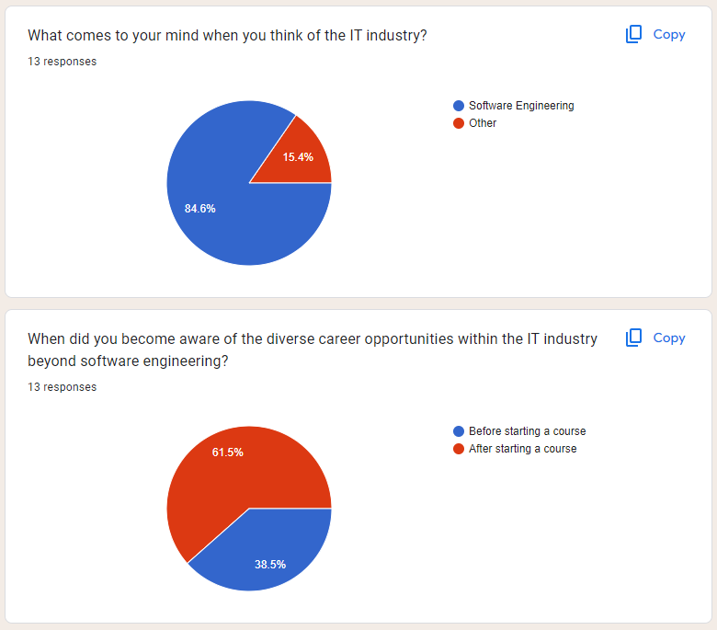

Figure01 - understanding of the IT industry

# PROPOSED SOLUTION

## 2.1 Project Proposed

The Patocy Project centers on empowering individuals to discover fulfilling career paths aligned with their passions. It utilizes a multifaceted approach to achieve this goal. Firstly, the project delves into user interests and aspirations to identify their inherent passions. Secondly, it provides comprehensive knowledge about various career options, equipping users with the necessary information to make informed decisions. Ultimately, the Patocy Project strives to bridge the gap between personal passions and professional opportunities, fostering a future where individuals can pursue careers they are genuinely enthusiastic about.

Following the initial career exploration phase, the Patocy Project transitions into a personalized consultation stage. Recognizing the importance of expert guidance, the project connects users with industry professionals aligned with their chosen career path. These consultations provide users with a unique opportunity to gain valuable insights directly from experienced individuals. Through in-depth discussions and personalized recommendations, users can refine their career aspirations, addressing any lingering questions or concerns. This tailored approach empowers users to make confident and well-informed decisions regarding their future career path.

Recognizing the vast array of educational pathways available, Patocy group understands the challenges individuals face in navigating these options. To address this, the project goes beyond simply identifying suitable careers. It empowers users by curating a personalized list of relevant educational resources. This includes suggesting courses, degree programs, and scholarship opportunities aligned with their chosen career path. By providing this comprehensive overview, Patocy group aims to minimize the regret often experienced by individuals who were unaware of their educational options. This proactive approach ensures users have the necessary knowledge to make informed decisions about their chances of success in their chosen careers.

## 2.2 System Diagram

The user will send requests from the server and according to the request, The server will manage to give responses and if it needs to use generative ai then the server will request from generative ai and give responses to the user.

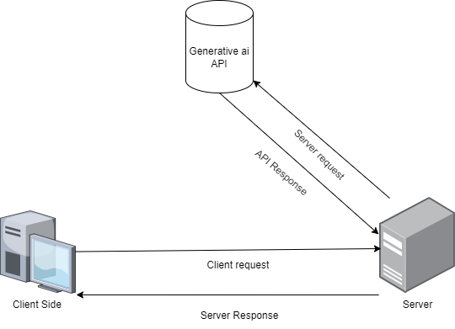  
Figure01 - understanding of the IT industry (self-composed)

# TARGET AUDIENCE

Our platform also addresses the needs of people with specific career goals and interests within IT, such as software development, cybersecurity, data science, and more. Whether they're focusing on becoming programmers, network engineers, or IT consultants, our resources provide valuable insights and direction to offer assistance to help them make strong decisions. Additionally, our platform functions as a valuable resource for educational institutions, offering insights into the latest trends and requirements in the IT job market. By utilizing our platform, institutions can way better adjust their curricula to meet the needs of students and ensure they are prepared with the skills and knowledge demanded by the industry. With the offer assistance of our platform, users can investigate different career paths in the IT field, access resources for skill development and career advancement, and make informed decisions to improve their overall career prospects in the dynamic and ever-evolving world of technology.

## 3.1 High school and college students

Some students lack the necessary experience to make future decisions. After they got the A/ls, they were confused. This group of students includes those who are going into the IT industry, and all of them pursue SE or CS degrees thereafter. However, none of them know what their interests or talents are, so they all follow what they have heard from others. They can use our platform to self-study and get a clear idea more easily than if they searched Google.

## 3.2 Career changers seeking new opportunities

After working for such a long time, some of the people mentioned become disinterested in their chosen field and look for better opportunities in the IT industry, such as remote employment. Secondly, their previous employment was entirely unrelated to the IT path they later took, so they were unsure of what they needed to choose. Then they get confused, and sometimes they get lots of stress from their new job.   
Sometimes they can't easily understand what they want, and they don't have the time to learn this kind of programming, like graduate students. Because of that, our platform is so simple that they can stand and provide courses they can complete in their free time.

## 3.3 Guidance counselors

Seniors have some difficulties working with freshers because they don't have the skills the industry is looking for. if they can get in touch with newcomers. Then long-time IT professionals can both discover new sources of income and impart their skills to newcomers.

## 3.4 Education institutes

Universities, colleges, and vocational schools are providing many certificate courses, diplomas, and degree programs. Sometimes lots of students come from after A/Ls and enroll in one program, in that case, they can't provide facilities to all these students. then they need to limit their intake. From our solution, we reduce that traffic and divide that student into various paths. And in that case, they can provide new programs and improve income using the same facilities. they can combine with us and promote their business as well.

# FEATURES OF THE SYSTEM

Below are the features we are implementing:

| **Features** | **Description** | **User role** | **Priority** | **Dependency** |
| --- | --- | --- | --- | --- |
| Account creation | Users can create new accounts | All users | Must | - |
| Account Login | Users can log in to their accounts | All users | Must | Account creation |
| Role-based page navigation | Users can navigate to pages which are accessible to the role of them | All users | Must | Account Login |
| Determine the passion | User can determine their passion after our AI is asked few questions about them | Registered user (Industry looker) | Must | Account Login |
| Book Consultancy | Users able to book consultants | Registered user (Industry looker) | Must | Account login,  Role-based page navigation |
| Pay for consultancy | Users can pay for consultants to book them | Registered user (Industry looker) | Must | Book Consultancy |
| Generate receipts | The system will generate receipts for users(industry lookers) and consultants | Registered user (Industry looker) | Could | Pay for consultancy |
| Add reviews and ratings | Users can add reviews for consultants | Registered user (Industry looker) | Could | Pay for consultancy |
| Display career according to passion | The system will display careers to the user according to the determined passion of the user | Registered user (Industry looker) | Must | Account login,  Role-based page navigation |
| Show Degrees to the given career | The system will display Degrees to the user according to the determined passion of the user | Registered user (Industry looker) | Must | Display career according to passion |
| Show courses and links | The system will display Courses to the user according to the determined passion of the user | Registered user (Industry looker) | Must | Display career according to passion |
| Show average salaries | The system will display average salaries to the user according to the determined passion of the user | Registered user (Industry looker) | Should | Display career according to passion |
| Show career Guidance | The system will display career guidance to the user according to the determined passion of the user | Registered user (Industry looker) | Must | Display career according to passion |
| Generate reports | The system will generate reports to the user according to the determined passion of the user | Registered user (Industry looker) | Could | Display career according to passion |
| Show earnings for the consultants | The system will display the total earnings for the consultant | Registered user (Consultant) | Could | Account login,  Role-based page navigation |

# RESOURCE REQUIREMENT

## 5.1 HARDWARE

To ensure smooth operation and optimal performance while working with our system, the following hardware specifications are recommended:

* Processor: Dual-core processor
* RAM: Minimum of 2GB

These specifications are designed to support the development and running of our web application effectively. While these are the minimum requirements, we suggest using more advanced hardware for enhanced performance and a smoother user experience.

## 5.2 SOFTWARE

Given that we are developing a web application, it is essential to have a compatible web browser. We highly recommend using Google Chrome due to its superior performance, developer tools, and compatibility with modern web technologies. **Google Chrome** will facilitate efficient testing and debugging, ensuring a robust and reliable application.

Developers,  
 IDE: VSCode

Database: MongoDB  
UI tools: Figma, Photoshop  
Documentation tool: Google Docs

## 5.3 TECH STACK

Our development will be based on the **MERN** stack, which includes the following technologies:

* **MongoDB**: A NoSQL database that offers flexibility and scalability. MongoDB is well-suited for handling large volumes of data and allows for efficient querying and indexing.
* **Express.js**: A web application framework for Node.js. It provides a robust set of features to develop web and mobile applications. Express is known for its fast and minimalistic approach, which makes it ideal for building APIs and handling server-side operations.
* **React** A front-end library developed by Facebook, used for building user interfaces, particularly single-page applications where data can change over time. React's component-based architecture allows for reusability and efficient state management, resulting in a dynamic and responsive user experience.
* **Node.js**: A JavaScript runtime built on Chrome's V8 JavaScript engine. Node.js allows for server-side scripting using JavaScript, making it possible to build scalable network applications. It is renowned for its event-driven, non-blocking I/O model, which makes it lightweight and efficient.

# BUSINESS MODEL

A business model is a plan that shows how a company creates, delivers, and captures value. It describes the way a business makes money by specifying its value proposition, target customer segments, revenue streams, cost structure, key resources, and partnerships. Basically, it’s a blueprint for how the company operates and achieves profitability.

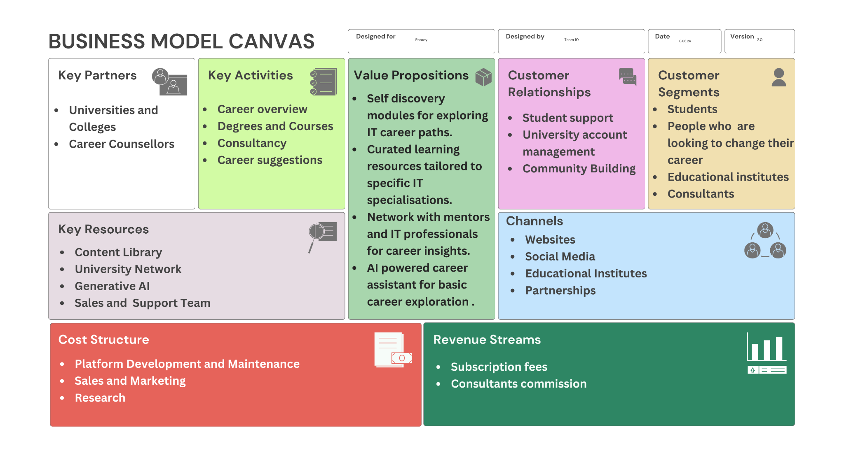

# REVENUE MODEL

**Revenue Model:**

Patocy will employ a B2B (business-to-business) approach, focusing on partnerships with Sri Lankan universities and colleges offering IT related degree programs. We will also introduce a new revenue stream through partnerships with career counselors.

**Revenue Streams:**

* Program Listing Fees: Universities will pay a monthly fee to list their IT degree programs on the Patocy platform. This fee will be based on a unique pricing structure that incentivizes wider student engagement.
* Flat Fee with Usage Based Adjustment: We will offer a single, standardized monthly subscription fee for all universities, regardless of program size or student body. This ensures a fair and transparent pricing structure.
* Counselor Commission: Counselors will set their own fees, and Patocy will earn a 3% commission on each successful counseling session booked through the platform.

**Financial Projections:**

* Market Research: Analyze the number of universities offering IT programs in Sri Lanka and estimate their potential budget for online advertising and student recruitment.
* Subscription Fee Determination: Research industry standards for university targeted online platforms and factor in development and operational costs to determine a sustainable monthly subscription fee.

**Projected Growth:**

We project to establish partnerships with 11 universities and colleges within the first year of operation, generating revenue through program listing fees. As the platform gains traction and student engagement increases, we anticipate significant growth in lead generation fees and potential future subscription revenue.

# ADVERTISING

Social media marketing: Utilize targeted campaigns on platforms popular with students, such as Facebook, Instagram, and YouTube.

Edu Fairs and Career Fairs: Collaborate with schools, colleges, and universities to promote Patocy to students through events.

Search Engine Optimization (SEO): Implement effective SEO practices to ensure high visibility in search results for relevant keywords.

# COMPETITOR ANALYSIS

Figure01 - Competitor Analysis Table

# NEXT STEP

Patocy app aims to provide users with personalized career advice in the IT field based on their skills, interests, and market trends. This proposal outlines the development plan for creating a minimum viable product. We will serve as the foundational version of the app to validate care functionalities and gather user feedback.

Now we are in the crucial design phase of our project. This phase involves planning the features and functionalities that our product will offer. During this stage, our design and development teams are working collaboratively to create a comprehensive blueprint that outlines the user interface (UI) and user experience (UX), technical architecture, and overall work floor of the product. This detailed planning is essential to ensure that the subsequent development stages proceed smoothly and that the final product meets the needs and expectations of our users.

## 10.1 Feature Sets

After the design phase, we will move into the implementation phase. Now, we will start coding and integrating the various feature sets as outlined in our design documents. This phase is iterative and involves constant testing and debugging to ensure that each feature functions correctly and integrates seamlessly with the rest of the system. Our goal is to build a strong and functional prototype that can be subjected to rigorous testing.

## 10.2 Alpha Testing

Following the implementation phase, we will enter the alpha testing stage. Alpha testing is an internal process where the initial version of the product is tested by us and select internal testers. The primary objective during the alpha testing is to identify and fix critical issues, ensure that all features work as intended, and make any necessary adjustments based on the testers’ feedback. This stage helps to improve the stability and usability of our product before it is visible to a larger audience.

## 10.3 Beta Testing

Then we can proceed to beta testing. Beta testing involves releasing the product to a broader group of external users who will test the product in real-world conditions. These testers will provide valuable feedback on the product’s performance, usability, and overall user experience. This feedback will be instrumental in identifying any remaining issues, gathering insights into user preferences, and making final adjustments before the official launch. The goal of beta testing is to ensure the product is ready for market release and meets the highest standards of quality and reliability.

## 10.4 Marketing Field

After the Beta Testing, we can shift to marketing the product. Our marketing strategy will employ a variety of techniques to maximize the product’s reach and ensure its success in the marketplace. This will include digital marketing campaigns, social media engagement, influencer partnerships, email marketing, and possibly traditional marketing methods such as print ads and events. We hope to build brand awareness, generate excitement, and attract a large user base through targeted and strategic marketing efforts.

## 10.5 Continuous Maintenance and Improvement

We regularly update the product to fix any emerging issues, enhance existing features, and add new functionalities based on user feedback and market trends. We will dedicate ourselves to providing prompt and efficient assistance to users, ensuring satisfaction, and addressing any issues we encounter. So, we will monitor the product’s performance and user engagement metrics to inform ongoing development efforts and ensure the product remains competitive and relevant.

According to this structure, our project development and release plan encompasses a through and structured approach from the initial design phase through to continuous post-launch maintenance. Each phase is critical to ensuring the success of the product, from detailed planning and rigorous testing to marketing and ongoing improvements. By following this comprehensive plan, we focus on delivering a high-quality product that meets user needs and significant market success.

# SUMMARY

We aim to guide individuals in the IT industry towards careers aligned with their passions and identify the common issue of stress and dissatisfaction among those who choose software engineering without genuine interest. We help users make informed decisions about their professional paths by offering comprehensive career exploration tools, personalized consultations with industry experts, and tailored educational resources. We target high school and college students, career changers, guidance counselors, and educational institutions, providing features like career guidance, consultancy booking, and access to relevant courses. Not only these things but also we hope to offer both freemium and premium subscription models, along with partnerships with educational institutions and online platforms for additional revenue. Our app is the only app is specializes IT industry and Integrated AI into the platform. Also, we follow a structured development plan, including design, implementation, testing phases, and a robust marketing strategy to ensure a successful launch and continuous improvement.

# REFERENCES

Marathe, A & Wagani, R 2022, ‘Role of Passion in Career Choices of University Students: A Mixed Method Study’, *Journal of Positive School Psychology*, vol. 2022, no. 5, pp. 109–118.

LeBourdais, G.P. (2023). *Why Passion is Important for Success in Work and Life | Polygence*. [online] www.polygence.org. Available at: <https://www.polygence.org/blog/why-passion-is-important-for-success>.  
  
Anon, (2021). *Passion Project - IEG Global Association*. [online] Available at: https://ivyedugrp.org/passion-project/.